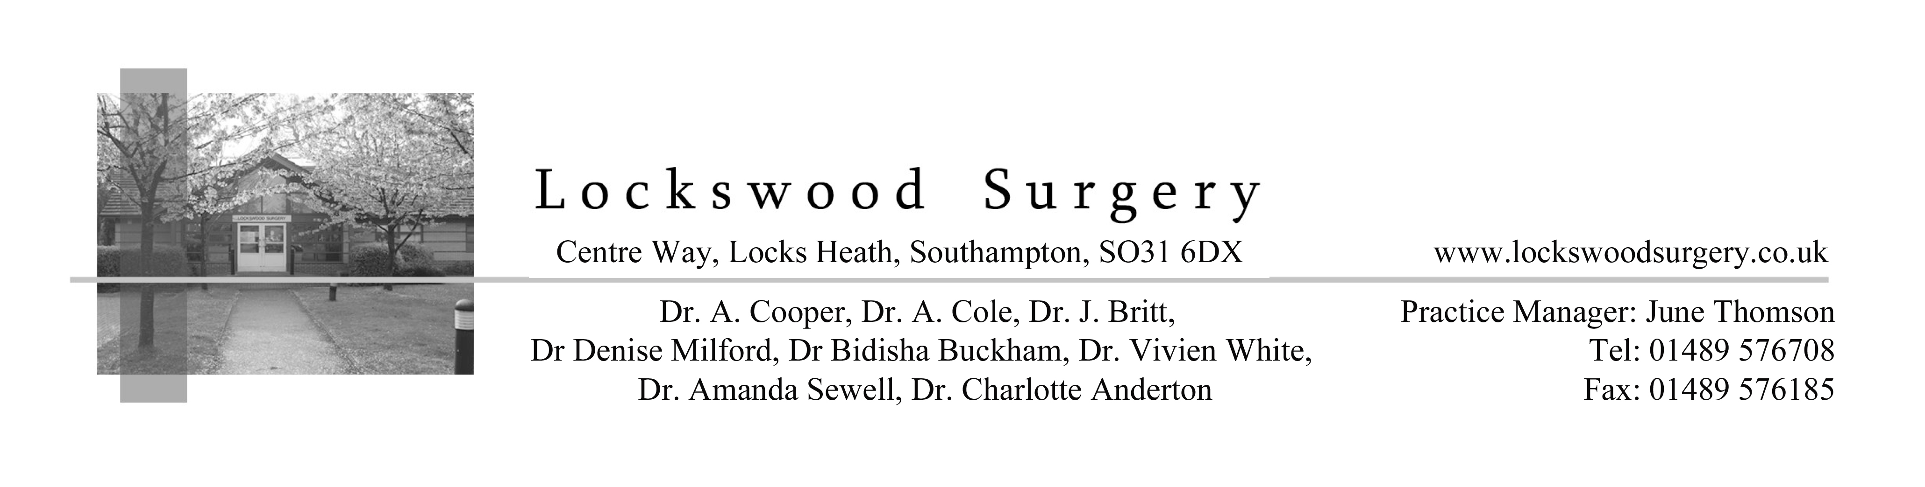
Application for online access to my medical record

Surname | Date of birth
First name
Address

Postcode
Email address
Telephone number | Mobile number
I wish to have access to the following online services (please tick all that apply):
1. Booking appointments | □
2. Requesting repeat prescriptions | □
3. Accessing my medical record | □

I wish to access my medical record online and understand and agree with each statement (tick)
1. I have read and understood the information leaflet provided by the practice | □
2. I will be responsible for the security of the information that I see or download | □
3. If I choose to share my information with anyone else, this is at my own risk | □
4. If I suspect that my account has been accessed by someone without my agreement, I will contact the practice as soon as possible | □
5. If I see information in my record that is not about me or is inaccurate, I will contact the practice as soon as possible |  □
6. If I think that I may come under pressure to give access to someone else unwillingly I will contact the practice as soon as possible. |  □

For practice use only
Signature
Date
Patient NHS number |  |  | Practice computer ID number
Identity verified by (initials) | Date |  | Method  Vouching □  Vouching with information in record □  Photo ID and proof of residence □
Authorised by |  |  |  | Date
Date account created
Date passphrase sent
Level of record access enabled  All □  Prospective □ Retrospective □  Detailed coded record □  Limited parts □ |  | Notes / explanation

V5 27 January 2016

